How to Manual

Student’s Name
Department, University
Course Number and Name
Instructor’s Name
Date
How to Manual
Introduction
A manual is a technique for keeping the front wheel off the ground while you roll on the rear wheel. A manual look exactly like a wheelie the only difference is that instead of pedaling for it to propel to your front wheel up it is started by moving your bodyweight towards the back of the bike. Manuals help to increase your speed and efficiency on the trail. They are smoother and quicker than the wheelies because they can get over bumps like water bars or little roots, and they help you to carry speed through bumpy sections of the trail. Manual is not as easy as wheelies because a rider can effortlessly manual down a road for ages. One needs a whole load of time and practice before perfecting it into a manual (Bialosky et al., 2018).
There are two parts to the manual, which is getting the front wheel in the air and finding the balance to keep it there. The main key to both parts is using your body weight and not your legs or arms. To get the front wheel up the ground you need to preload and punch. To preload the suspension, you need to push your weight down into the bike. This will give you some rebounding energy that will help get the wheel up. Punching time is as soon as you are low over the seat (Bialosky et al., 2018). As quick, as you can push your feet and arms forward and throw your weight back. You need to keep your arms locked straight so that it is your weight that brings that wheel up rather than pulling the wheel up with your arms. You should note that trying to lift the bars with just your arms would drop your chest forward, which will then force the wheel down. The secret to keeping the bike balanced is to keep even pressure on both sides of the handlebar and both pedals.
Now that the wheels are up, your work is holding it up there by balance. Balancing is all in the hips, you need to keep your hips low and over the back wheel, and also move them forward and back to stay in balance. Your finger should be kept on the rare brake. This will help you when you feel like you are going to tip backward because you will just tap the brakes once and your front wheel will dropdown.
Tips When Learning How-To Manual
There are a few tricks one needs to have in mind when practicing to master this great technique. The first trick is to understand that it is all in the hips. A good manual technique starts with your hips and bums, not your arms. When learning the manual, you will find many riders struggling to find the initial balance point by lifting the front wheel harder and higher which can never help them to stay up (Bialosky et al., 2018). One should not think about pulling too hard with your arms, as an alternative thinks about sliding your bum off the back of the saddle and get your hips in the line with the rear hub in one smooth movement. This helps with taking the weight off the front wheel and one should not apply too much effort from the arms to get the manual off the ground and into the all-important balance point.
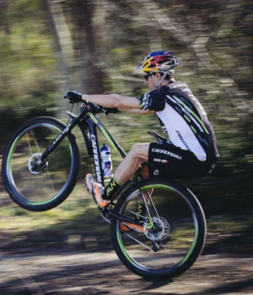
After finding the balance point, the next technique is for helping you keep yourself there. The second technique is also in the hips and legs but now, it is your arms, which should remain straight, and you should have a bend in your legs. Your legs should remain extended a little and hips dropped back in case the front wheel begins to drop. Your shifting of weight should be subtle but keeping the front wheel in the air should be made the cornerstone (Erickson et al., 2017).

All the balance of maintaining a manual will come from the shifts in your body weight, so when the manuals are dialed you should cover the rear brake. When you are learning, a how-to manual for the first time, you are afraid of looping out of the manual and coming down hard on your backside that can actually happen and it can hardly hurt. The rare break should be your friend and a quick dab while up there will quickly bring the front end straight back down if you feel yourself going, this will help save your backside from unprepared meeting the ground.
When learning how to manual a high seat can hinder your progress. Lowering the seat will make the job of finding the balance point much easier. A high seat will not make it impossible to manual anyway, but lowering it makes it easier.
Yes, you can learn to manual any bike, but some bikes are easier to manual than others are. Bikes, which are easier to the manual, are bikes with riser bars and a high front end; they should be easier as less of your weight in your arms. Bikes with short chainstay that keep your back wheel closer to the bottom bracket will also be slightly easier. Bikes with flat pedals are normally easier for they help riders in developing some confidence when starting, as it is easier to jump off the back if you do end up looping out.
Range of Motion
Ranging in motion works in both directions. Most riders will throw their hips back, but their chest, head, and upper body will not move at all. One should note that to bend your elbows and get your head low to start, that way when you throw your weight back, you have taken a bigger swing at it. This will give you more potential energy and will allow you to put more weight into the rocking back that you are trying to create. In turn, and with a bit of practice, this will open up time to react. A short, fast, violent throw is very difficult to gauge. A longer sweeping movement will feel like you have more time and warning, and mean that you can get a better feeling of control.
Drops
When it comes to drops, the big fear is that your front end will dive and you will go over the handlebars. To stop this from happening, go fast and kind of speed hop so that the bike stays level in the air (Erickson et al., 2017). This will help you if you are going first enough not when you are going slowly or when the drop is above a certain height. Driving your front end up the same as a manual by pushing with your legs is the correct way of neutralizing it and stopping it from plummeting down. If you can manual properly then, then drops of any size are easy. To be able to apply this to a drop, you only need to be able to manual for the length of your bike. A drop is trying to throw your weight back at just the ride time to stop the dive, and then be able to get back into a neutral riding position while falling so that you can come down.
Practice time
When trying to manual through, you should note that drainage ditches and puddles are no different. You should always try to come in low and close to the bike. Rock your weight back as same as a manual. Always start small with a line on the ground and try to time your manual to get your wheel up over a small stick. Once you have the timing nailed, you can take it to the trail. During practice time, the first step is you start by rolling along at a medium pace. As you start, you should not be slow as balancing will become difficult at slow speeds (Erickson et al., 2017). Doing manuals in context on the trail is easier because the rear wheel is falling away into the obstacles. You should practice on the flat and your manuals will greatly improve.
The second step is shifting your body weight in front of the bike gently. This should not be done aggressively, as it is only used to create the forward momentum. The third step during practice is, in the fluidity, you should shift your body weight at the rear of the bike and gently pull on the handlebars. The fourth step during practice is when you are on the rear wheel; try to find the balance point using your brakes and legs.
The fifth step is, when you feel like you are going too high, you could just bend your knees a little bit or tap the rear brake gently. The sixth step during practice time is when you feel you are going too forwards, immediately straighten your legs and pull on the handlebars until you reach the balance point. The last step is adjusting your sideways balance by using your knees and handlebars. You should note that, if you are going to the right side, stick your left knee out, turn your handlebars to left, and if you are going to the left side, stick your left knee out and turn your handlebars to the right (Erickson et al., 2017)
How the Choice of Bikes Affects How-To Manual?
Every bike has a different tipping point. This is a good way of gauging how a bike will handle once you get used to it. Bikes that have larger wheels have a much bigger circumference, this will force the rider to have to lever the thing off the ground, then push loads using legs to control it once it is up. As you push your legs into the balance point and back off again to bring it back down, you will have to really exaggerate it to work your way over that large tipping point. This has an advantage because; a wide tipping point means a lot of stability at speed.
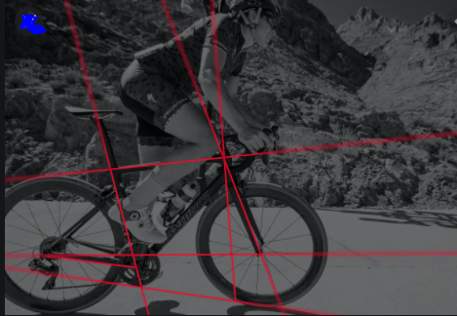
Fig: The bike geometry
A smaller and narrow wheel with a short back end on the other hand will be a lot easier to get up, but very twitchy once it is up there due to the smaller overall circumference and thus a steeper drops off either side of the balancing point. You can through it around quicker but that same platform is inherently unstable. Going between two different bikes will be very strange at first but it will help you to understand more about the tipping points of the different bikes than you realize. This is because, at first, anything different from what you are used to is almost impossible to get your head around.
What to Avoid When Learning How-To Manual
You should not pull up and bend your arms. Trying to compress the forks to gain spring and lift is another mistake that should be greatly avoided. You should not commit to pushing your body weight far enough back during the lift phase. Sliding weight backward but keeping head and shoulders too low should also be avoided. Do not go too fast or you will flip over. You should find a vast empty place so that you do not run on something.
Do not pull on the bars. As soon as a rider's front wheel comes off the ground, most riders tend to bend their elbows and lift the front wheel further. What this does is that it moves your body weight forward and restricts how far back you can go. If this is how you control your manual, it will go through your riding. Pulling on the bars is the very control mechanism that you are trying to undo. Alternatively, you should focus on getting low, to begin with, then pushing the bike forward and keeping your arms straight. After you throw the bike forwards and rock back you should be fairly still up top and all of the control over the balance point should then come from your legs (Bialosky et al., 2018).
Conclusion
In conclusion, how to manual is a trick that few masters, but is so far-reaching that once acquired you will look back on how you used to ride and think, how did I use to do this before I could manual? It is currently the backbone of modern riding.

References
American Library Association. the on-road control transitions. Accident Analysis & Prevention, 102, 227-234.
Bialosky, J. E., Beneciuk, J. M., Bishop, M. D., Coronado, R. A., Penza, C. W., Simon, C. B., & George, S. Z. (2018). Unraveling the mechanisms of manual therapy: modeling an approach. journal of orthopedic & sports physical therapy, 48(1), 8-18.
Eriksson, A., Banks, V. A., & Stanton, N. A. (2017). Transition to manual: Comparing simulator wi Hunter, G. S. (2020). Developing and maintaining practical archives: A how-to-do-it manual.

